CREATIVE AND PERFORMING ARTS | ST THERESA PRIMARY SCHOOL
1. Modelling-Sculpture  2. Post Office  3. Nutrients  4. Space and distance  5. Dance elements  6. Gymnastic movements  7. Striking/fielding games  8. Traditional music instruments |  | TERM 2
MODELLING-SCULTURE
Sculpture
It is a shape made by carving wood or stone, by casting metal or by modelling clay.

Difference between freestanding and relief sculpture
Relief sculpture | Freestanding sculpture
Is made on a flat surface, eg. Painting, drawing | Made from things that have form, eg. Clay, stone, metal
Cannot stand on its own | Can stand on its own, secured to the ground
It is 2-dimensional, can only be viewed from the front | It is 3-dimensional, can be viewed from all sides

Tools and materials used in sculpture making
Tool and material depend on the type of material used. For example:
Material | Tools
- Wood | - Chisel  - Mallet  - Glue gun  - Hammer  - Sand paper  - Ripsaw  - Trimming knife
- Clay | - Potter’s wheel  - Kiln
- Papier mache | - Newspaper, magazines  - PVA Glue (white)  - Masking tape
- Stone | - Chisel  - Hammer  - Sand paper
- Wire | - Pliers  - Straight tin snips
- Bronze | - Hacksaw  - Straight tin snips  - Chisel  - Glue gun

Various ways the post office delivers letters and parcels
- Surface mail
- Air mail
- Express mail

The reasons for sending documents by express or registration
- It is the quickest way of sending urgent mail.
- It is secure because mail is delivered to the recipient’s door step.
- Easy to track documents because they are registered.
- Compensation can be made if the documents are lost.

The transfer of money and parcels through the post office
Money can be sent through the post office in various ways.
- Money order
It is a postal money transaction that enables customers to send money or make payments through the Post Office. The sender fills in a form at the Post Office and pays the money. The Post Office notifies the receiving Post Office which in turn notifies the receiving customer.

- Postal order
Postal orders are money in the form of a voucher. The vouchers can only be cashed by the person named to receive the money at any Post Office in Botswana. Proof of ID is required.

- Telegraphic transfer
The money is handed to the post master who then makes a phone call or sends money fax to the destination post office. A receipt with a serial is a handed to the sender. The recipient is the notified to collect money at the destination post office.

- Money sent by post
Money can also be sent by post. It will take longer than telegraphic transfer but it will cost less. This method is risky as the money may get lost.

- Insured parcels
Parcels with valuable contents may need to be insured at additional costs. The value of the contents is indicated on the parcel. If the parcel is lost, the post office will reward the customer.

- C.O.D parcels
Cash on Delivery. The recipient pays for the cost of sending parcels.

NUTRIENTS
- Nutrients are substances found food that help the body stay alive and healthy.
- They have different sources and functions

Nutrients | Food source | Functions
- Proteins | Animal products, eg. Meat, eggs, fish, milk, cheese, chicken  Vegetables eg. Legumes (beans, nuts) | - Build tissues and cells.  - Repair worn out tissue and cells
- Carbohydrates | Maize, rice, sorghum, potatoes, bread, pasta, cereals | - Supply the body with heat and energy  - Fibre and roughage help in digestion
- Vitamins and minerals | All vegetables and fruits | - Formation of strong bones and teeth  - Prevents night blindness  - Maintains healthy skin  - Helps blood to clot
- Fats and oils (lipids) | Margarine, butter, bacon, meat, nuts, sunflower, olives, | - Provide the body with heat and energy  - Protect internal organs such as kidneys
- water | Fruits, beverages | - regulates body temperature  - transport substances around the body

Dietary guidelines
- These are rules that help people to eat healthy by eating a balanced diet.
- People must not eat too much or too little of one type of food.
- The amount of food eaten depends on age, body size, and activity done.
- A good diet should be supported by exercises.
- All food groups must be included in a meal in their correct proportion.

Balanced meal
A balanced meal contains all foo groups (nutrients) in their correct proportion.
Example of a balanced meal
Breakfast | Lunch | Supper
Fruit salad  Scrambled eggs  Sausage  Banana milk shake | Papa  Roasted meat  Salads  Vegetable soup  Fruit juice | bread with butter  cheese omelet  raw vegetables  tea or coffee  Fruit

MODULE 2: COMMUNICATION
SPACE AND DISTANCE

- DRAWING
Graphic art (picture) made with a pencil, pen or charcoal.

Different ways of creating the illusion of space and distance in drawing
An illusion a:
- A distortion of optic senses.
- A misleading image presented to the optic senses

Examples of illusion in drawing

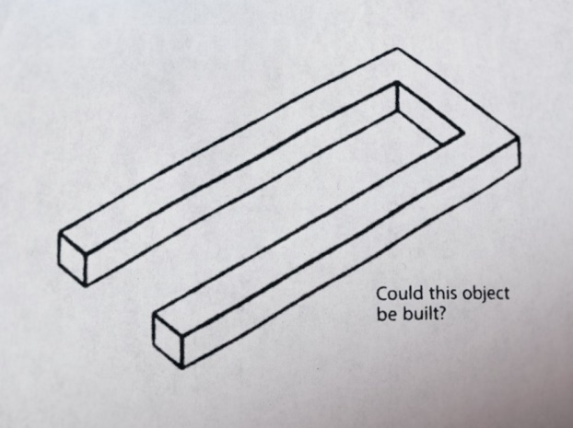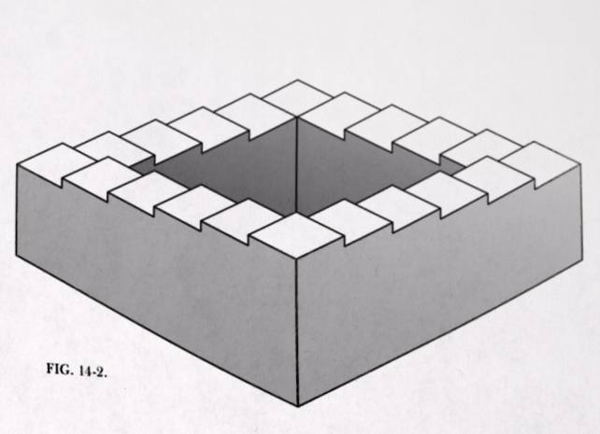

Illusions can be created by:
- Perspective
It is used when drawing objects on a flat surface (2-D).
- To create perspective:
- Objects or figures that are far away (background objects) are drawn smaller and objects that are near (foreground objects) are drawn much bigger.
- Objects that are far away (background) are drawn higher on the picture than objects that are nearer (foreground).
- A path, road or river is drawn wider and lower at the starting point (foreground) and becomes narrower towards the vanishing point (background).

Examples of perspective in drawing

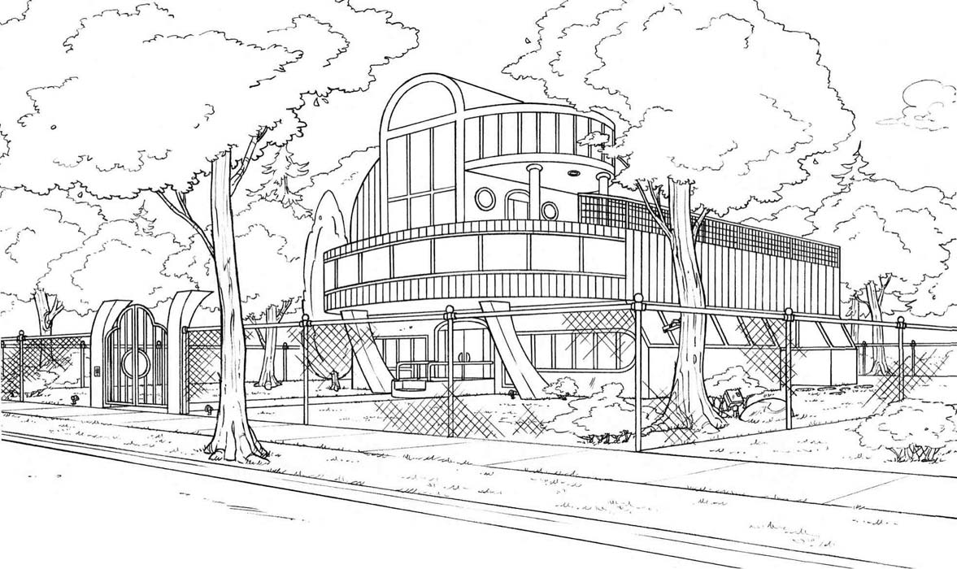

- Vanishing point
- Two parallel lines, such as a road, railway line or a river seem to be moving towards each other. The point where the lines come together (meet) on the horizon (background) is the vanishing point.

Examples of vanishing point in drawing
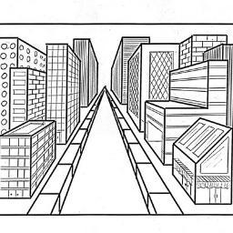

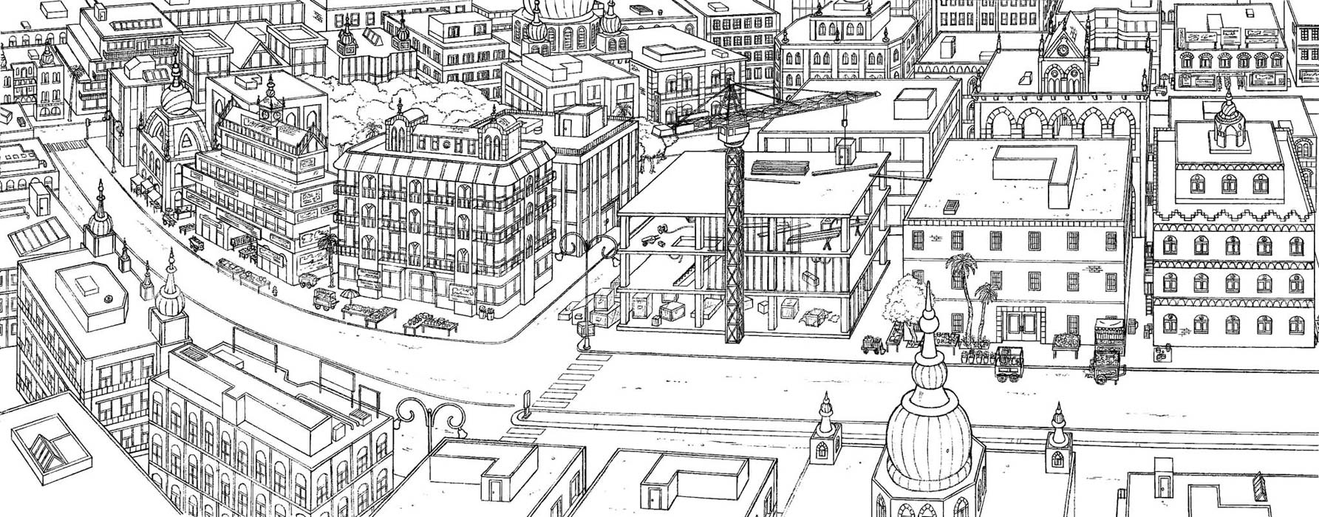

- PAINTING
Graphic art composed of applying paint to a surface.

Ways of creating the illusion of space and distance in drawing
- The further an object, the smaller it will look and the higher it will be placed in painting.
- A road, path or stream will become narrower towards the background until it vanishes at the horizon.
- The walls and roofs of houses seem to get narrower towards the background.
- Colours that are bright and intense seem to be nearer than colours that are dull, pale or hazy.
- The illusion of distance can also be created by putting more details into parts of the picture that are nearer than parts that are far away.

UNIT 3.2: CREATIVE DANCE
DANCE ELEMENTS
Different dance elements are linked together to make a particular dance.
- Pathways
The pathways are the different ways and directions in which the body moves.

- Relationship
In a dance, parts of the body are in relationship to each other. Where more than one dancer takes part, the dancers are in relation to each other. The dancers must:
- Move towards or away from each other
- Move in the same direction or in opposite directions
- Follow the leader
- Move simultaneously

- Speed
The speed of movement is the time that it takes to perform a movement. The steps or arm movements may be fast, slow, quick or unhurried. The duration of the movements may be short or long.

- Locomotive
These movements involve travelling along the floor, eg, stepping or running.
A step can be made in different directions: forwards, backwards, sideways

Differences between Rhythm and Coordination
- Rhythm
- It is everything that relates to the timing of music.
- It is created by patterns of long and short sounds.
- It may be created from handclaps, foot stamps, drum beats or songs.

- Coordination
- The organisation of movements of all parts of all parts of the body.
- Movements are coordinated according to a rhythm pattern.
Awareness of personal space and general space
Space
- It is an empty area.
- It allows dancers to move.
- It can limit a dancer’s movements.

Types of space
- Personal space: the space closer to the dancer
- General space: it means shared space
- Negative space: it refers to unoccupied personal space.
- Positive space: refers to occupied personal space.
Effort awareness and relationships
- Dancers warm up before practicing their dances.
- Warming up allows the body to loosen up be and ready to be moved and twisted in different directions to avoid injury.
Relationships
- Relationship in dance apply to:
-movements, steps or styles
-partners

Co-operative and social skills in dance
People dance together for many reasons, eg.
- As a way of socializing
- Communities come together during important social events such as wedding ceremonies
- People may dance together in dance troupes
- As a school, you may dance together because you belong to the same club
- Dancing may be done for commercial purposes

Choreography and dance
- Choreograph: means to compose and arrange dance steps.
- Choreography: notes and signs made to represent movements and steps in dance.
It is a form of writing notes in dance.

- Choreographer: is someone who composes and arrange dance steps.
For dancers to remember a dance, a choreographer would make notes and sketches of the dance.

Different patterns and styles in dance
- Ethnic dancing eg, tsutsube, setapa, borankana etc
- Folk dancing
- Ballet
- Ballroom dancing
- Modern dancing

Significance of dance in the community
- Entertainment
- Source of employment
- Used to pass message
- Educational purposes
- Used to express feelings
- Cultural purposes

UNIT 3.4: BALL GAMES
STRIKING/FIELDING GAMES

- STRIKING GAMES
An object is used hit the ball, eg.
Striking game | Materials used
- Badminton | - Net  - poles  - racket  - shuttle-cock
- Table-tennis | - Bat  - table tennis ball  - poles
- Squash | - Wall  - ball  - racket
- Tennis | - Racket  - tennis ball  - tennis shoes

- FIELDING GAMES
Fielding game | Materials used
- Football | - Football  - Pitch  - Poles  - Net  - Keeper’s gloves  - Soccer boots
- Netball | - Poles  - Net  - Ball
- Volleyball | - Poles  - Net  - Ball
- Softball | - bat  - helmet  - spikes  - gloves

Sending and receiving skills for different games
Game | Sending skills  (Directing the ball to a teammate) | Receiving skills  (Means stopping the ball)
- Football | - Passing (head pass, shoulder pass, leg pass)  - Crossing | - Trapping (leg, shoulders, head)
- Netball | Throwing (side pass, overhead pass, shoulder pass | - Catching (one or both hands)
- Volleyball | Spiking, volleying, digging, servicing | - Blocking
- Softball | - Pitching  - Throwing | - Batting  - Caching
- Badminton | - Serving  - Smashing | - Blocking
- Tennis | - Serving  - Smashing | - Blocking

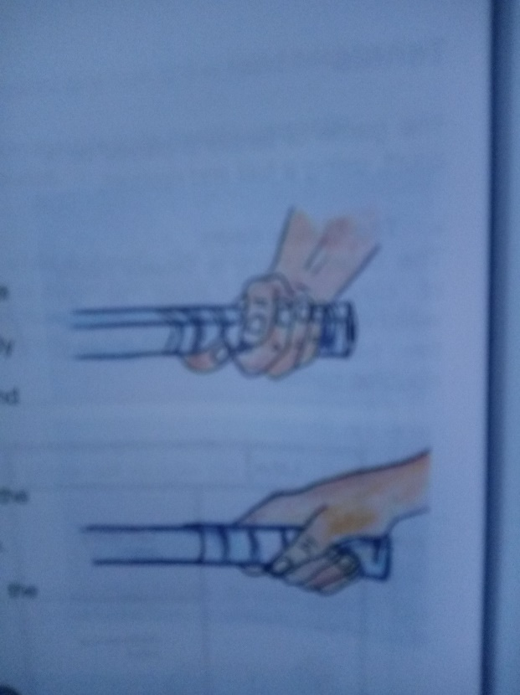
Proper grip/hold and stance for the selected game

The forehand grip
- The fingers wrap around the grip
- The thumb rests along the handle
- The index and middle fingers are spread
- The hand is wrapped partly around the butt of the racquet
- The grip is made by the little finger and the butt of the hand

The backhand grip
- The index finger is wrapped around the grip
- The thumb is closed around the handle

Court dimensions for different games

- Football pitch

- Netball pitch

- Badminton

- Table-tennis

UNIT 3.5: MUSIC OF BOTSWANA
TRADITIONAL MUSIC INSTRUMENTS

Traditional instruments of Botswana origin.

Percussion instruments |  |  | Wind instruments |  |  | Stringed instruments
They make sound when you bang, shake, scrape or pluck them. |  |  | Sound is made when wind is blown into or over holes in the instruments |  |  | Sound is made when the strings are pulled, plucked, scraped or hit with a stick.
Example | Materials | Sound | Example | Materials | Sound | Example | Materials | Sound
Moropa/  Drums | Animal skins, hollow wood | Bass | Naka/flute | Hollow reed |  | Segaba | Tin, string, wood/  plank
Marimba | Wooden bars, tubes | Bell or organ | Pala/horn | Cow horn |  | Lengope | String, cane/stick
Matlhoa/  Leg rattles | Moth cocoons | Rattling sound | Ditlhaka/ Reed pipes | Hollow reeds |  | Segwana | Sting, stick (cane)
Marapo/  Clappers | Rib bones from cattle
Setinkane | Wood, metal tongues | Tang
Mogorogorwane | Seedpods from baobab

